**Daniel Williamson**

**Project #1**

**9/9/16**

**CS 212**

Project Overview

Purpose:

The purpose of this project was to simply get a website up. Nothing fancy, just some text. We will do this by using WinSCP and a simple text editor.

Approach:

To begin this project, I needed to download WinSCP and learn how to work it. I have never used WinSCP nor have I ever built a website. So this was a first for me. I also used Atom as my text editor, because I am familiar with it and it is simple. Once I had my text editor and WinSCP It was rather easy.

Results

These are my results:

I added a title icon for fun. But I titled my website Thunder. And then I added a body were I had some fun adding a photo.

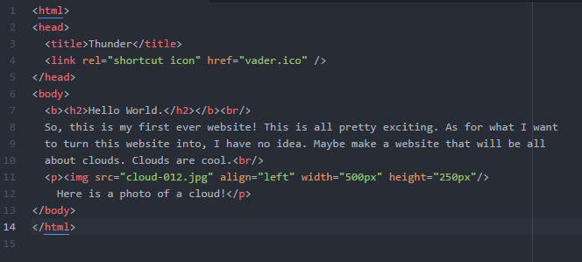

Testing:

This is my output. Pretty simple and I am excited to get to work on it some more throughout the semester.

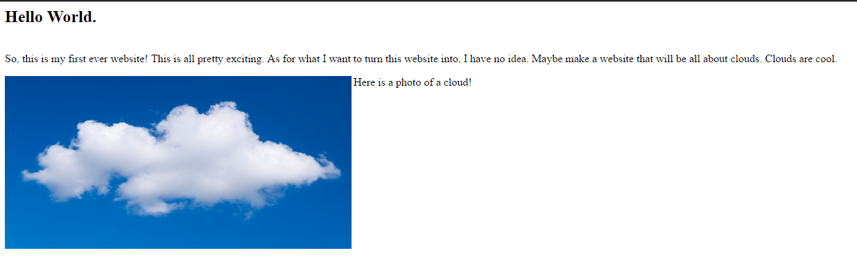

Conclusion

In conclusion this was a rather easy project. The only confusion I had was uploading the webpage to the server. I met up with some peers and they were able to give me a hand. I had difficulties with the title icon because I had accidently placed it within the title tag. Took me a while to figure out my mistake.